Steps to create BTP Trial Account and BAS Dev Space
- Click on https://www.sap.com/products/technology-platform/trial.html

- Click on Try Now button and enter your email ID:

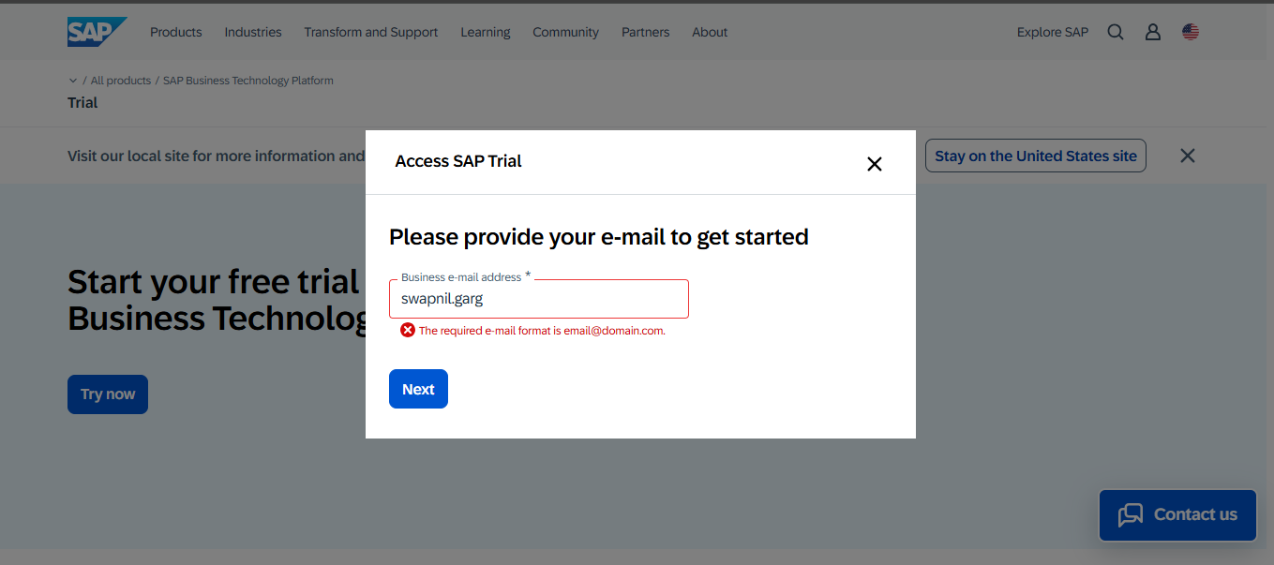

- Enter further information:

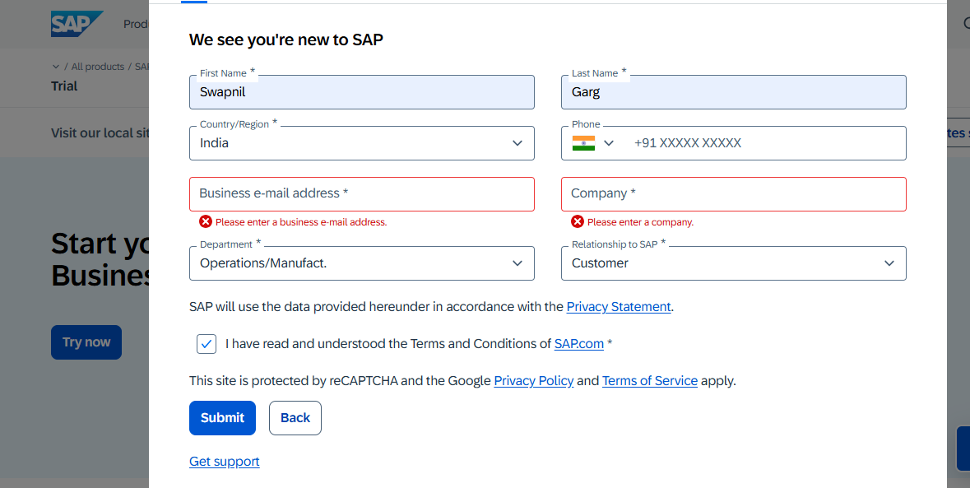

- You will receive a mail on the provided email ID to activate your account.

- After clicking on the Activate button, provide further information.

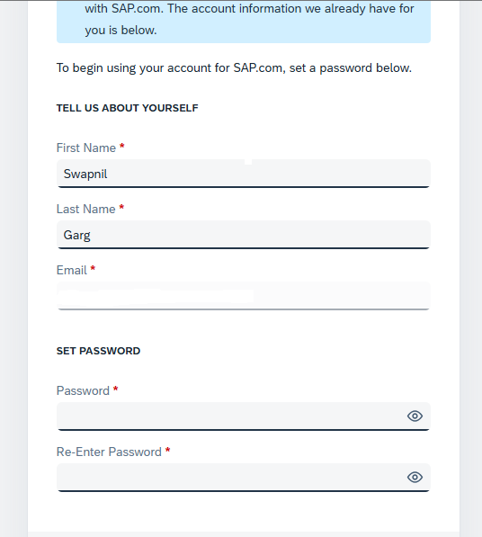

- Click Continue
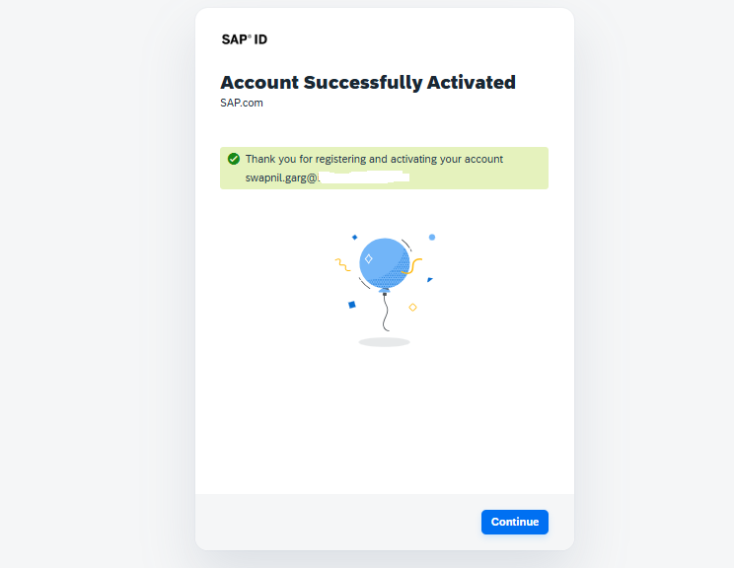

- Click on ‘Click here to start your trial’ button:

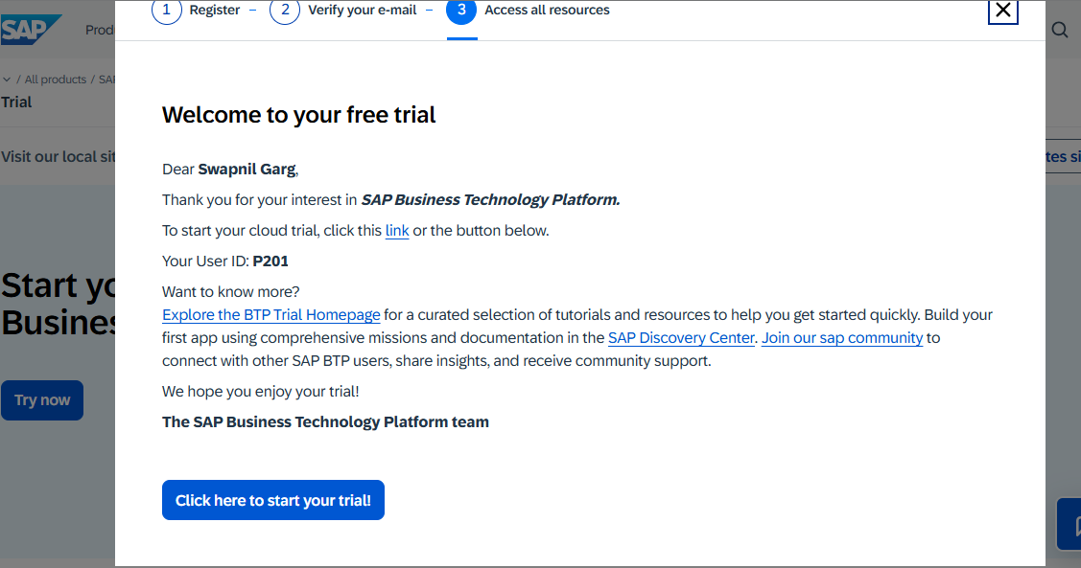

- You will be asked to input the code sent on your provided mobile no.
- You will be navigated to the cockpit now. Select Singapore – Azure and click Create account.
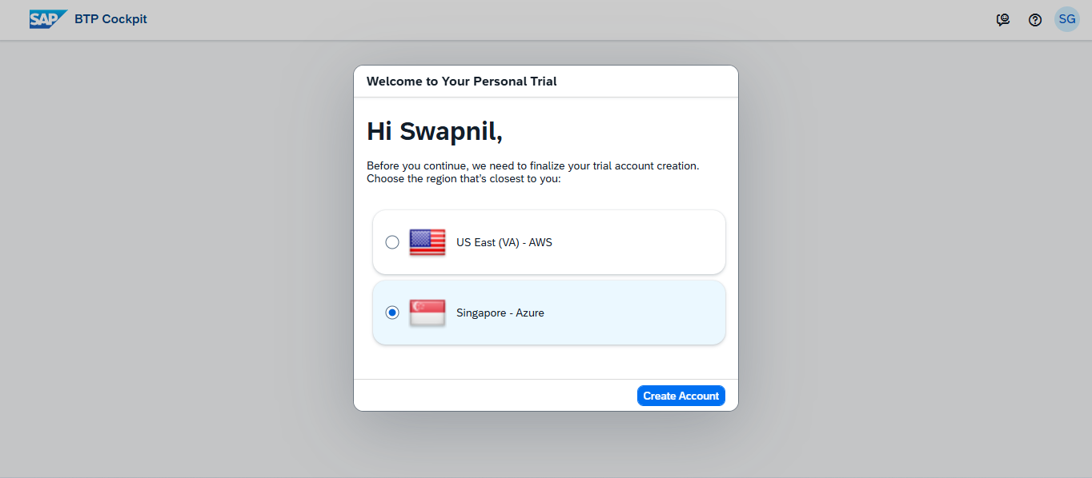

- Hit Continue after the Processing is done.

- Click on SAP Business Application Studio

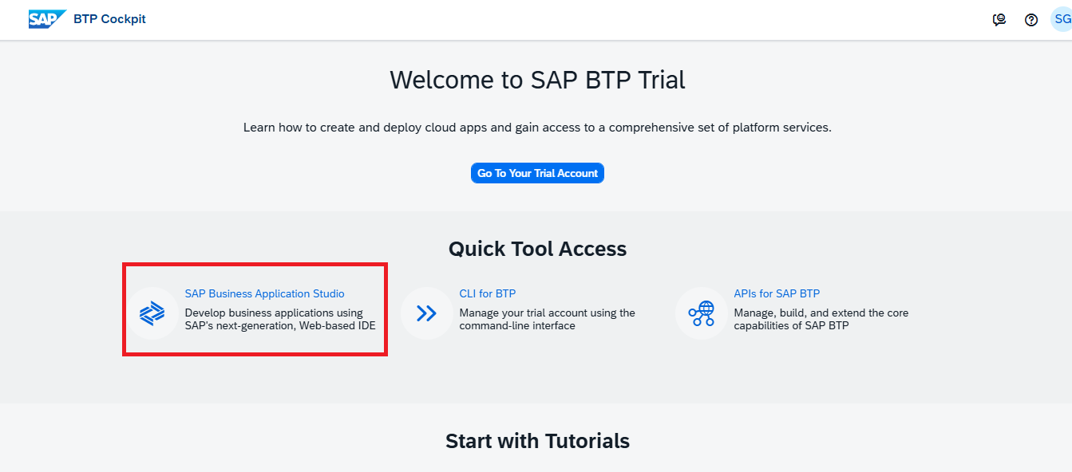

If this doesn’t take you to the SAP BAS link, then follow the below steps otherwise move to the Step no. 12.

11 A) Click on ‘Go to your trial account’ button

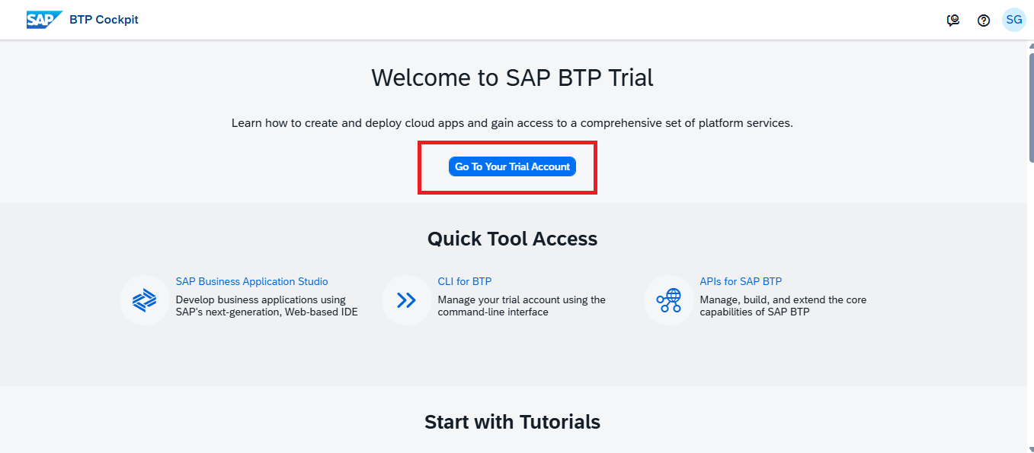

11 B) Click on ‘trial’ subaccount

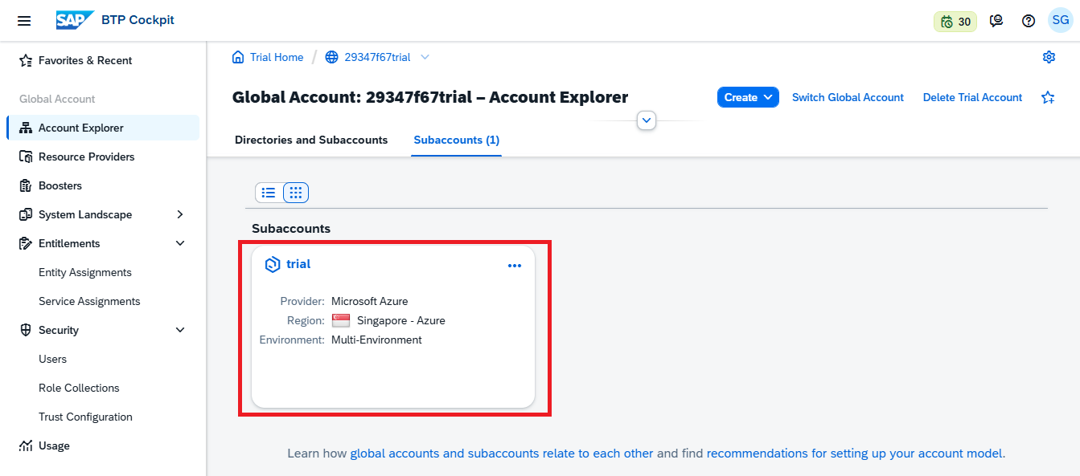

11 C) Click on ‘Instances and Subscriptions’ tab under Services section in the left

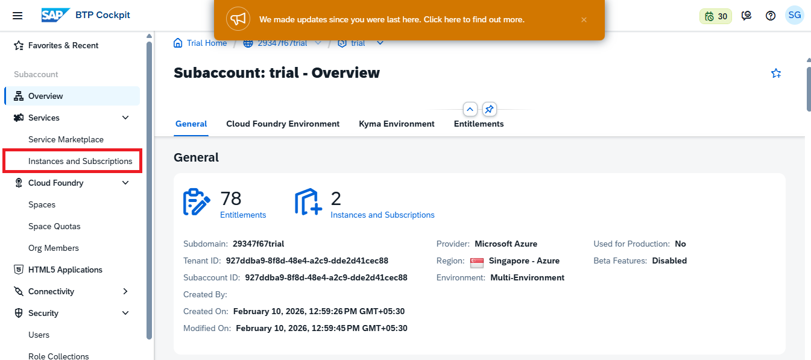

11 D) Click on SAP Business Application Studio

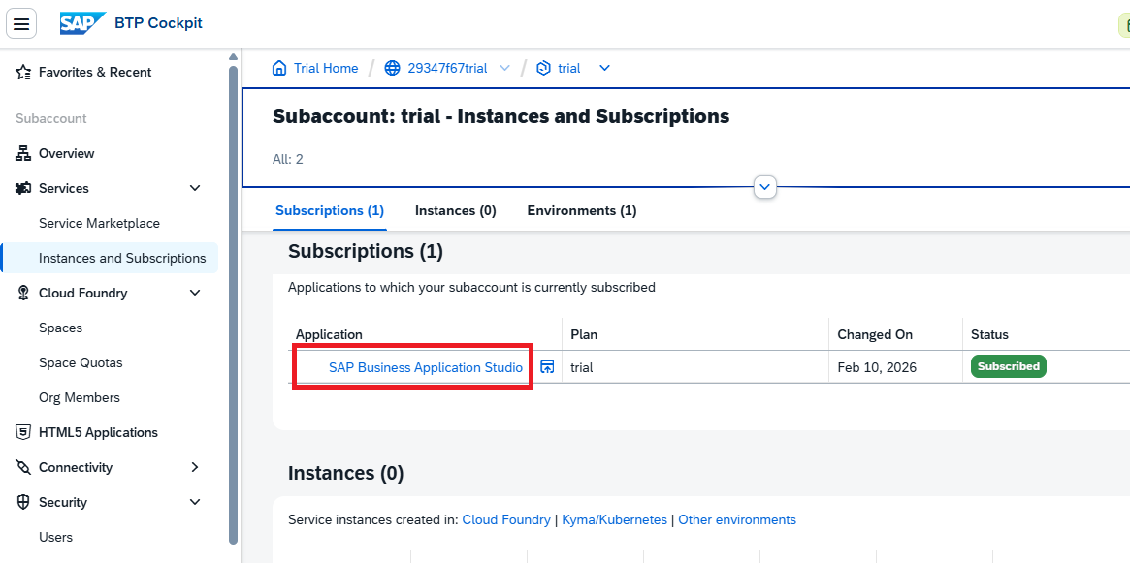

- Bookmark the URL so that it would be easier to open BAS and click OK.
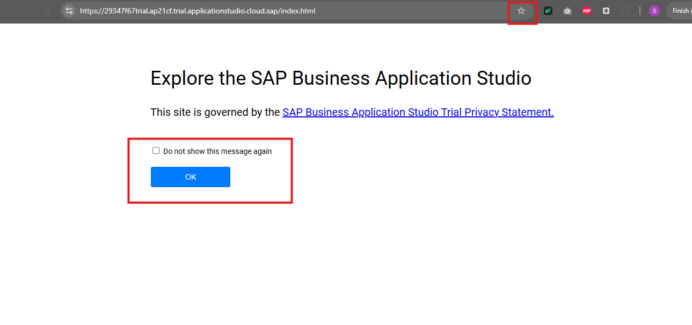

- Click Create Dev Space

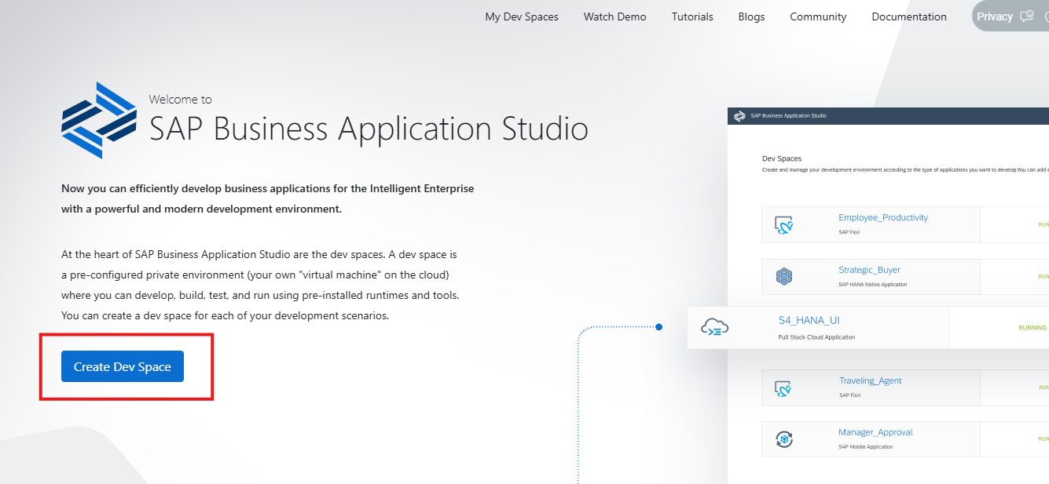

- Enter the Dev Space name, select SAP Fiori and click the ‘Create Dev Space’ button.
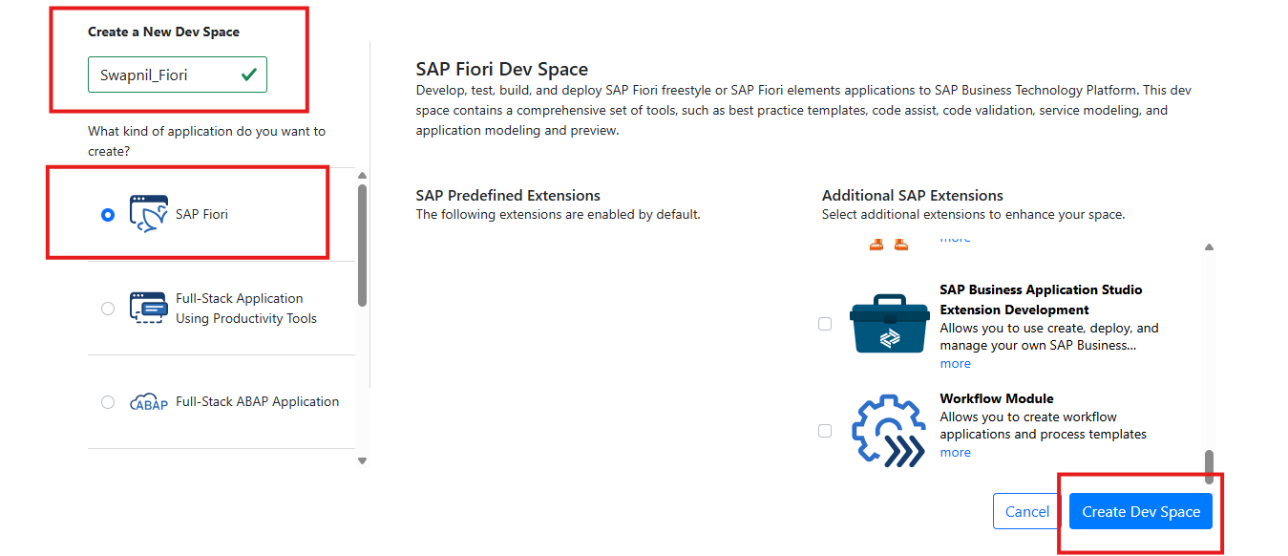

- Click on the Dev space name once it is in ‘Running’ state.
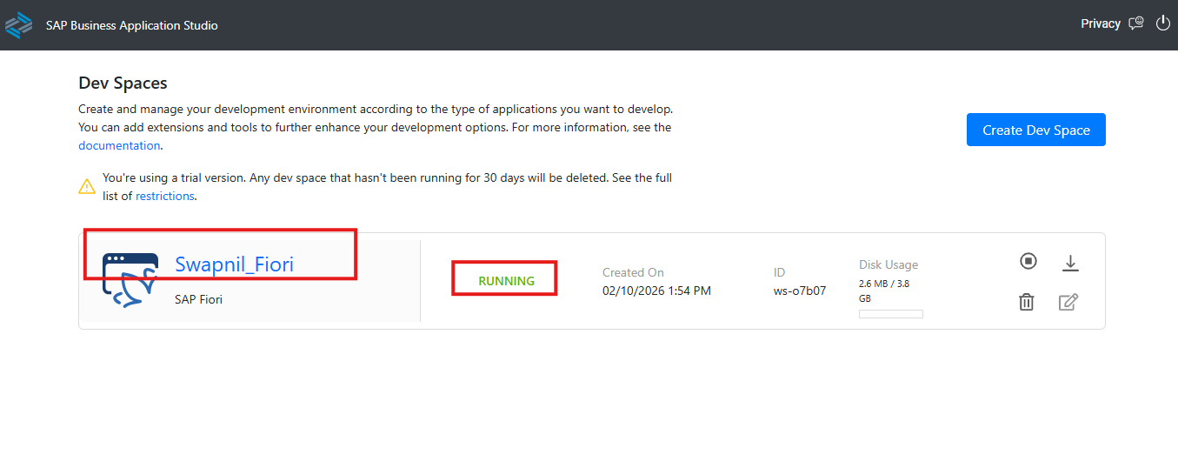

- Your IDE will be opened :
